Hill Country Land Conservation Online Workshop
Friday, October 2, 2020 from 9 AM – 12 PM

9:00 Welcome and Introductions
- Daniel Oppenheimer – Hill Country Alliance
- Brad Roeder – Gillespie County AgriLife Extension
- Mark Steinbach – Texas Land Conservancy
- Tiffany Osburn – Hill Country Land Trust

9:20 Land Stewardship – Steve Nelle, USDA Natural Resources Conservation Service, Retired

9:40 Key Issues for Rural Landowners and Ranchers – Jim Bradbury, James D. Bradbury, PLLC

10:15 Break

10:25 Tax and Financial Considerations of Conservation Easements – Margaret Menicucci and Kathryn Tancig, Braun & Gresham Attorneys at Law

11:00 Financial Cost-Sharing Opportunities – Shane Kiefer, Plateau Land and Wildlife Management

11:30 Landowner Discussion Panel

11:50 Recap and Wrap Up

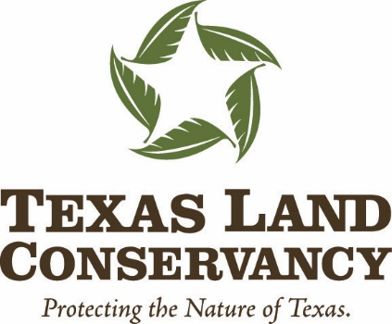
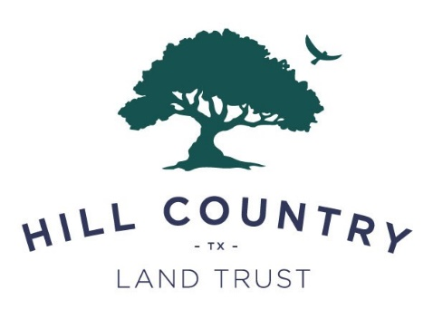
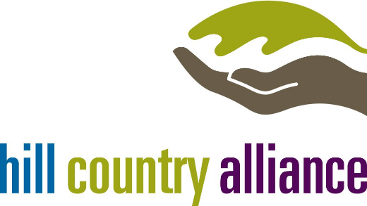

~With Support From~
Gillespie County AgriLife Extension, Braun & Gresham, Plateau Land & Wildlife Management, and James D. Bradbury, PLLC

