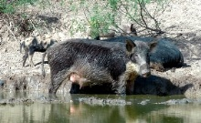
Taylor County
Feral Hog Trapping
Eradication 101
101

Taylor County & Texas A & M Agrilife Extension
Invites you to join us on
June 28, 2018
8 a.m. - 9:30 a.m.
For Coffee & Donuts
Taylor County Expo Grounds
1801 East S. 11th, Abilene, TX

Trap Demonstration at 8:00 a.m. at Griffin Arena
With USDA Trapper - Matt McCloy
Special Guest Speaker:
Josh Helcel, Texas A&M Natural Resources Institute
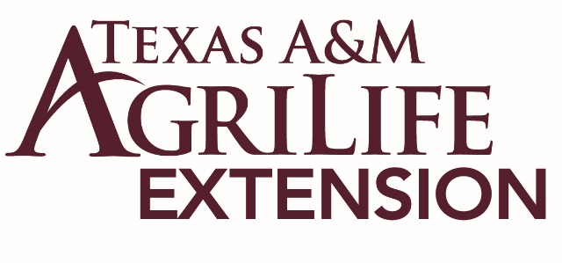
@ 8:30 a.m. Big Country Hall

Please RSVP to Texas A &M Agrilife Extension by June 22nd
@ 325-672-6048

