Urban Quail Appreciation Day
Hosted by TAMU Quail Decline Initiative

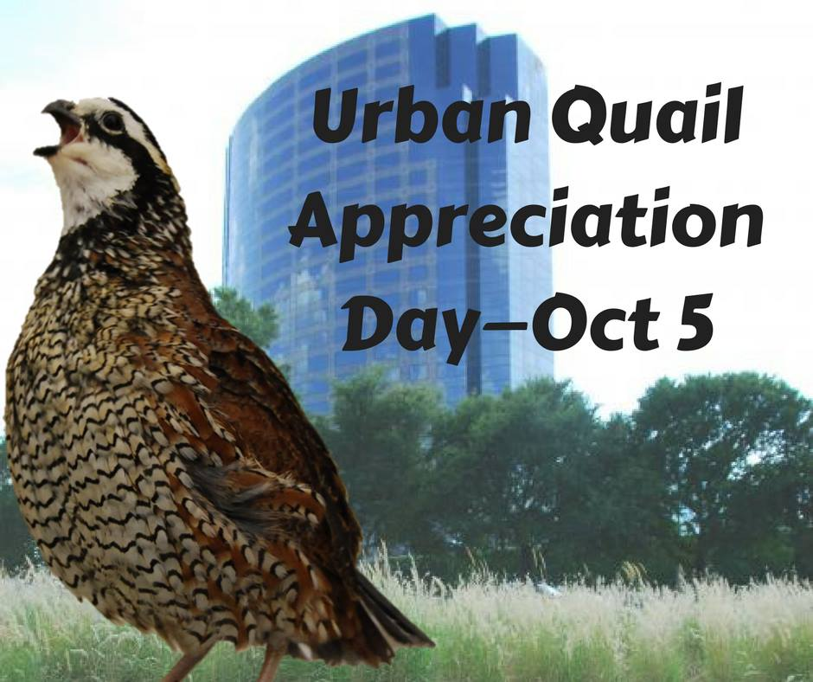
Oct. 5, 8 a.m. – 4 p.m. | Witte Museum, 3801 Broadway St, San Antonio, Texas 78209
8:30 a.m. Registration and refreshments; CEU paperwork
9:00 Welcome
9:05 What’s Your Quail IQ?
9:20 Becoming a “Student of Quail”
9:30 Getting to Know Your Quail (dissection)
10:20 BREAK
10:35 Scoring Quail Habitat – Would you put your dogs out here?
11:00 Evaluating Quail Habitat
11:30 Plant Succession webisode
11:45 Bobwhite Brigade cadet and/or QuailMaster presentation
Noon LUNCH
12:30 p.m. Word from Sponsors
12:45 Show Me the Money – Economic Impacts of Quail Hunting in TX
1:15 Predation Management and Quail
Run for Your Life
The Mortality Mile
2:30 Dummy nest webisode
2:45 Hawks & Quail webisode
3:00 BREAK
3:15 Food & Water Strategies
Food plots webisode
Bugs & Bobwhites webisode
4:00 Wrap-up
4:15 Complete Evaluations

